# Introduction

Dalmia Cement (Bharat) Limited, a distinguished entity in the Indian cement industry, stands as a testament to innovation and growth in the infrastructure sector. Founded in 1939, the company has carved out a significant presence across the country, driven by a commitment to excellence and sustainability.

Headquartered in New Delhi, Dalmia Cement boasts an extensive production capacity, projected to reach approximately 56 million tons per annum by the end of FY 2024. This impressive scale is a result of strategic expansions and key acquisitions, including the impending acquisition of JPA’s cement and power businesses, which alone will add 9.4 million tons to its capacity​.

Dalmia Cement’s operational efficiency is noteworthy. In the first nine months of FY 2024, the company achieved a 9% year-on-year growth in cement volumes, underpinned by robust demand from government infrastructure projects and the residential housing sector. This growth is complemented by a strategic reduction in power and fuel costs, which has bolstered the company’s operating margins​

From a financial perspective, Dalmia Cement is a compelling prospect in the stock market. Despite a recent correction of about 20% in its stock price, the company’s long-term growth trajectory remains strong. Analysts predict that Dalmia Bharat’s strategic expansions and expected volume growth of 13% to 15% in FY 2022 justify its current valuations, making it a potential candidate for investors looking for substantial returns​

As Dalmia Cement continues to enhance its capacity utilization and deliver industry-leading volume growth, it solidifies its position as a key player in India's burgeoning cement industry. The company's relentless pursuit of operational excellence and strategic market positioning makes it not only a cornerstone of India's infrastructure development but also an attractive investment opportunity for discerning investors.

# Industry Profile:

## Their Vision:

To unleash the potential of everyone we touch.

## Their Mission:

To be in the top two in all our businesses on the strength of our people and the speed of our innovation.

## History:

Imagine a company that transforms not just landscapes but lives. Dalmia Cement (Bharat) Limited stands as a beacon of innovation, sustainability, and excellence in the Indian cement industry, continually pushing the boundaries of what's possible. Since its inception in 1939, Dalmia Cement has grown exponentially, not merely by expanding its production capacity but by redefining the very essence of industrial success.

With its roots deeply embedded in New Delhi, Dalmia Cement has embarked on a journey of relentless growth and transformation. By FY 2024, the company aims to reach an astounding production capacity of 56 million tons per annum, a testament to its ambitious vision and strategic foresight. This expansion is not just about numbers; it's about meeting the growing demands of a nation on the rise, fuelling infrastructure projects that lay the foundation for future generations.

Dalmia Cement’s commitment to operational excellence is unparalleled. In the first nine months of FY 2024 alone, the company achieved a 9% year-on-year growth in cement volumes. This remarkable feat is driven by a deep-seated ethos of efficiency and sustainability, as the company continuously innovates to reduce power and fuel expenses, thereby enhancing its operating margins.

But what truly sets Dalmia Cement apart is its unwavering dedication to sustainability. In an era where environmental concerns are paramount, Dalmia Cement leads the charge with eco-friendly manufacturing processes that significantly reduce its carbon footprint. This commitment not only aligns with global sustainability goals but also inspires a new generation of businesses to prioritize the planet alongside profit.

Strategically positioned across various high-demand regions in India, Dalmia Cement leverages its extensive market reach to ensure resilience and sustained growth. This geographical diversity mitigates regional demand fluctuations, making the company a robust pillar in the Indian cement landscape.

From a financial perspective, Dalmia Cement's story is one of resilience and promise. Despite market volatilities, the company’s stock remains a beacon for investors, buoyed by consistent volume growth and strategic expansions that promise stable and lucrative return.

Dalmia Cement (Bharat) Limited is more than just a company; it’s a vision for a brighter, more sustainable future. It exemplifies how business can be a force for good, driving progress and prosperity while safeguarding our planet. For anyone looking to be inspired by a story of innovation, resilience, and visionary leadership, Dalmia Cement is a shining example of what can be achieved when passion meets purpose.

## Description about Finance Department:

The Dalmia Cement (Bharat) Limited is taking crucial Part in the Business as we see in all other business also the whole Finance Department is managed by the Chief Financial Oficer of the company Mr. Dharmendar Tuteja and the finance department of Dalmiapurm(DPM) is managed by the Following Peoples.

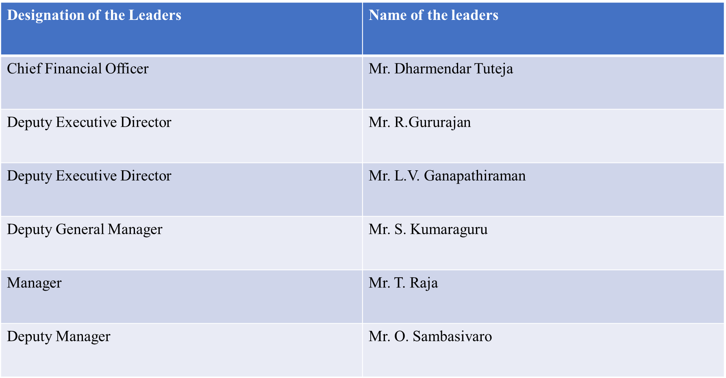

## Their USP:

Dalmia Cement (Bharat) Limited's Unique Selling Proposition (USP) lies in its comprehensive approach to growth, sustainability, and innovation, making it a standout player in the Indian cement industry.

1. **Extensive and Expanding Capacity:** Dalmia Cement is one of the largest producers of cement in India, with a projected capacity of approximately 56 million tons per annum by the end of FY 2024. This significant capacity is supported by both organic growth and strategic acquisitions, such as the acquisition of JPA's cement and power businesses, which will add an additional 9.4 million tons to its portfolio​.
2. **Operational Efficiency and Cost Management:** The company has demonstrated exceptional operational performance by effectively managing its power and fuel expenses. This efficiency has allowed Dalmia Cement to maintain healthy operating margins despite a competitive pricing environment. The decline in international and domestic fuel prices has further enhanced its operational profitability.
3. **Sustainability and Innovation:** Dalmia Cement is a leader in sustainable practices within the cement industry. The company has made significant strides in reducing its carbon footprint and implementing eco-friendly manufacturing processes. Its commitment to sustainability not only aligns with global environmental standards but also appeals to increasingly eco-conscious consumers and investors​.
4. **Strategic Market Positioning:** With a robust presence across various regions in India, Dalmia Cement benefits from a diverse market base. This geographical diversification helps mitigate regional demand fluctuations and enhances the company's market resilience. The company's strategic focus on high-demand areas, coupled with government-led infrastructure projects, supports sustained growth and profitability​
5. **Financial Strength and Investment Appeal:** Despite market volatilities, Dalmia Cement remains an attractive investment due to its strong financial performance and growth potential. The company's stock has seen corrections, but its long-term outlook is positive, driven by consistent volume growth and strategic expansions. This makes Dalmia Cement a compelling choice for investors seeking stable returns in the infrastructure sector​

Overall, Dalmia Cement's USP is anchored in its substantial capacity, operational efficiency, commitment to sustainability, strategic market presence, and strong financial performance, positioning it as a leader in the Indian cement industry and a valuable investment opportunity.

# Organisation chart:

The Following are the Organisation chart of the company

Yadu Hari Dalmia

Non-Executive Director



Puneet Yadu Dalmia

Chief Executive Officer (CEO)



Goutam Dalmia

Managing Director (MD)





Anuradha Mukherjee

Independent Director



Anuj Gulati

Independent Director



Haigreve Khaitan

Additional Independent Director

Niddodi Subrao Rajan

Non-Executive Director





Dharmendra Tutreja

Chief Financial Officer

Haigreve Khaitan

Additional Independent Director



Rajeev Bansal

Chief Transformation officer





Udaiy Khanna

Head Human Relations

Ganesh Girkundwar

National Manufacturing Head





L.V. Ganapathiraman

Head Finance and Accounting

Rajeev Kumar

Company Secretary (CS)



## 

Officer

Senior Officer

Assistant Manager

Deputy Manager

Senior Manager

Assistant General Manager

Deputy General Manager

General Manager

Senior General Manager

Assistant Executive Director

Deputy Executive Director

Senior Executive Director

Chief Operating Officer

Chief Executive Officer

Executive Director

# Product Profile:

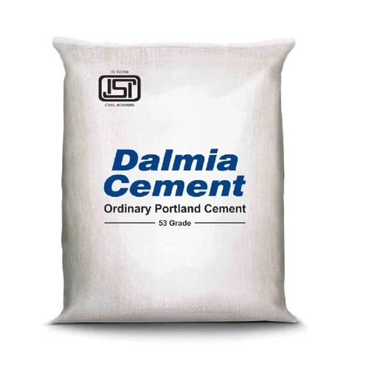

**Ordinary Portland Cement (OPC)**

Ordinary Portland Cement (OPC) is a widely used type of cement, renowned for its versatility and high performance. It is the most common type of cement used in general concrete construction when there is no exposure to sulphates in the soil or groundwater. OPC is composed primarily of clinker (a mixture of limestone and clay heated to a high temperature), gypsum (added to regulate setting time), and other minor constituents. The primary chemical components include calcium silicates, aluminates, and ferrites.

**Characteristics and Properties:**

1. **High Strength:** OPC achieves high early strength and long-term durability.
2. **Setting Time:** Initial setting time ranges from 30 minutes to 45 minutes, while the final setting time can be up to 10 hours.
3. **Grades:** Available in three grades in India - 33 grade, 43 grade, and 53 grade, indicating the compressive strength of the cement in N/mm² after 28 days of curing.
4. **Fineness**: OPC has a fineness of about 2250 cm²/gm to 3000 cm²/gm, affecting the rate of hydration and strength development.

**Applications:**

1. **Residential and commercial constructions:** Used in constructing buildings, bridges, roads, and other infrastructural projects.
2. **Precast Concrete Products:** Employed in the production of concrete blocks, tiles, and pipes.
3. **RCC Structures:** Widely used in reinforced concrete structures due to its high compressive strength.

**Price Details of Ordinary Portland Cement by Dalmia Cements**

Dalmia Cement is a prominent Indian cement manufacturer offering a range of cement products, including Ordinary Portland Cement. The price of OPC can vary based on several factors such as the grade of the cement, the region, and market conditions.

**General Price Range:**

**OPC 33 Grade:** Approximately INR 300 to INR 350 per 50 kg bag.

**OPC 43 Grade:** Approximately INR 320 to INR 370 per 50 kg bag.

**OPC 53 Grade:** Approximately INR 340 to INR 400 per 50 kg bag.



**Portland Pozzolana Cement (PPC)**

Portland Pozzolana Cement (PPC) is a type of blended cement that incorporates pozzolanic materials, such as fly ash, volcanic ash, or silica fumes, which are added to ordinary Portland cement. These materials react with calcium hydroxide in the presence of water to form compounds with cementitious properties. PPC is known for its improved durability and resistance to various chemical attacks.

**Characteristics and Properties:**

1. **Enhanced Durability:** PPC exhibits superior resistance to sulphates, chlorides, and alkali-silica reactions, making it suitable for structures exposed to harsh environmental conditions.
2. **Longer Setting Time:** The initial setting time is slightly longer compared to OPC, which can be advantageous in hot weather conditions or for large-scale concreting operations.
3. **Reduced Heat of Hydration:** The slower rate of hydration reduces the risk of thermal cracks in large concrete structures.
4. **Environmental Benefits:** The use of pozzolanic materials reduces the clinker content, thus lowering the carbon footprint of the cement production process.
5. **Cost-Effective:** Typically, PPC is more economical than OPC due to the use of supplementary materials like fly ash.

**Applications:**

1. **Marine and Hydraulic Structures:** Ideal for dams, bridges, and piers due to its excellent resistance to sulphate and chloride attacks.
2. **Mass Concrete Works:** Used in large infrastructure projects like dams and foundations where lower heat of hydration is beneficial.
3. **Residential and Commercial Buildings:** Suitable for general construction purposes, providing durability and longevity to structures.
4. **Masonry and Plastering:** Preferred for masonry work and plastering due to its workability and smooth finish.

**Price Details of Portland Pozzolana Cement by Dalmia Cements**

Dalmia Cement is known for producing high-quality PPC, which is widely used across various construction projects in India. The price of PPC can vary based on several factors such as the location, market demand, and the specific composition of the pozzolanic materials used.

**General Price Range:**

PPC: Approximately INR 280 to INR 350 per 50 kg bag.

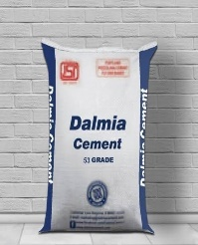

**Rapid Hardening Cement (RHC)**

Rapid Hardening Cement (RHC) is a special type of cement that is designed to achieve high early strength in a short period. This cement is similar in composition to Ordinary Portland Cement but has a higher content of tri-calcium silicate (C3S), which is responsible for the rapid hydration and strength gain.

**Characteristics and Properties:**

1. **High Early Strength:** RHC reaches significant strength within a few days, typically achieving compressive strengths comparable to 28-day strengths of OPC within 3 days.
2. **Faster Setting Time:** This type of cement sets faster than OPC, making it ideal for rapid construction activities.
3. **Higher Heat of Hydration:** Due to the rapid setting and hardening, RHC generates more heat during hydration, which can be beneficial in cold weather conditions.
4. **Durability:** Despite its rapid strength gain, RHC provides durable and robust structures.

**Applications:**

1. **Road Repair and Pavement Construction:** Ideal for projects requiring quick turnarounds, such as road repairs where minimal traffic disruption is desired.
2. **Precast Concrete:** Used extensively in the manufacture of precast concrete products to speed up production times.
3. **Rapid Construction Projects:** Suitable for emergency repair works, construction of structures requiring quick loading, and in areas with short construction windows.
4. **Cold Weather Concreting:** Useful in cold climates where the high heat of hydration helps in achieving desired strength despite low temperatures.

**Price Details of Rapid Hardening Cement by Dalmia Cements**

Dalmia Cement is a leading manufacturer offering various specialized cement products, including Rapid Hardening Cement. The price of RHC can be influenced by factors such as the region, availability, and market demand.

**General Price Range:**

Rapid Hardening Cement (RHC): Approximately INR 350 to INR 450 per 50 kg bag.



**Sulphate Resistant Cement (SRC)**

Sulphate Resistant Cement (SRC) is a specialized type of cement designed to improve the durability of concrete structures exposed to environments with high sulphate content. Sulphates present in soil, groundwater, and seawater can react with the compounds in standard Portland cement, leading to expansion and cracking of concrete. SRC minimizes this risk by reducing the tricalcium aluminate (C3A) content, which is highly reactive with sulphates.

**Characteristics and Properties:**

1. **Low Tricalcium Aluminate (C3A) Content:** SRC typically contains less than 5% C3A, reducing the potential for sulphate attack.
2. **Enhanced Durability:** Provides superior resistance to sulphate attack, making it suitable for use in harsh environments.
3. **Longer Service Life:** Structures built with SRC have a longer service life when exposed to aggressive sulphate environments.
4. **Moderate Heat of Hydration:** Generates less heat during hydration compared to OPC, reducing the risk of thermal cracking in large concrete pours.

**Applications:**

1. **Marine Structures:** Ideal for jetties, piers, seawalls, and other structures exposed to seawater.
2. **Foundations and Basements:** Used in areas with high sulphate content in soil or groundwater to prevent concrete deterioration.
3. **Sewage Treatment Plants**: Suitable for construction of sewage and wastewater treatment facilities, where exposure to sulphates is common.
4. **Industrial Structures:** Employed in the construction of chemical plants and other industrial facilities where sulphate exposure is a concern.

**Price Details of Sulphate Resistant Cement by Dalmia Cements**

Dalmia Cement, a well-known cement manufacturer in India, produces Sulphate Resistant Cement (SRC) that meets industry standards for durability and performance in sulphate-rich environments. The price of SRC can vary based on several factors including region, market demand, and specific project requirements.

**General Price Range:**

Sulphate Resistant Cement (SRC): Approximately INR 380 to INR 450 per 50 kg bag.

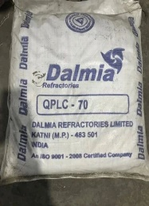

**High Alumina Cement (HAC)**

High Alumina Cement (HAC), also known as Calcium Aluminate Cement (CAC), is a type of cement that is distinguished by its high alumina content, typically above 35%. The primary ingredient of HAC is monocalcium aluminate (CaAl2O4). This cement is known for its rapid strength development and resistance to chemical attacks, especially in harsh environments.

**Characteristics and Properties:**

1. **High Early Strength:** HAC develops strength very quickly, achieving substantial compressive strength within 24 hours.
2. **Heat Resistance:** It is highly resistant to high temperatures, making it suitable for refractory applications.
3. **Chemical Resistance:** HAC offers excellent resistance to chemical attacks, including those from sulphates, acids, and alkalis.
4. **Low Lime Content:** The low calcium hydroxide content in HAC reduces the risk of alkali-silica reaction and other forms of deterioration.
5. **Fast Setting:** It has a quick setting time, which is useful for rapid repair and emergency construction works.

**Applications:**

1. **Refractory Concretes:** Used in furnaces, kilns, and other high-temperature industrial processes due to its heat resistance.
2. **Chemical Plants:** Ideal for structures exposed to corrosive chemicals.
3. **Sewer Infrastructure:** Suitable for sewage pipes and other infrastructure exposed to acidic conditions.
4. **Marine Construction:** Used in underwater and marine structures where resistance to sulphate attack is crucial.
5. **Rapid Repair Works:** Employed in situations requiring quick setting and early strength gain, such as emergency repairs.

**Price Details of High Alumina Cement by Dalmia Cements**

Dalmia Cement is a prominent manufacturer of various types of cement, including High Alumina Cement. The price of HAC can vary depending on factors such as the grade, region, and specific requirements of the project.

**General Price Range:**

High Alumina Cement (HAC): Approximately INR 600 to INR 900 per 50 kg bag.



**Hydrophobic Cement**

Hydrophobic Cement is a specialized type of cement designed to repel water and resist moisture penetration. It is manufactured by adding water-repellent chemicals to ordinary Portland cement clinker during the grinding process. These chemicals can include stearic acid, oleic acid, or other water-repellent additives that coat the cement particles, making them hydrophobic.

**Characteristics and Properties:**

1. **Water Repellences:** The primary feature of hydrophobic cement is its ability to repel water, which helps in protecting the cement from moisture-related damage.
2. **Improved Durability:** Hydrophobic cement is less susceptible to moisture-related degradation, such as freeze-thaw cycles and efflorescence.
3. **Reduced Capillary Action:** The water-repellent additives reduce the capillary action in concrete, thereby decreasing the absorption of water.
4. **Long Shelf Life:** Due to its resistance to moisture, hydrophobic cement has a longer shelf life compared to ordinary Portland cement, making it suitable for storage in humid conditions.

**Applications:**

1. **Waterproof Structures:** Ideal for the construction of basements, water tanks, dams, and other structures that require waterproofing.
2. **Marine Construction:** Suitable for building structures in marine environments where constant exposure to water is a concern.
3. **Subterranean Structures:** Used in the construction of tunnels and underground facilities where groundwater ingress can be an issue.
4. **Sewage and Water Treatment Plants:** Effective in environments where structures are exposed to wet conditions and need to remain durable.

**Price Details of Hydrophobic Cement by Dalmia Cements**

Dalmia Cement is known for producing a range of high-quality cement products, including specialized types such as hydrophobic cement. The price of hydrophobic cement can vary based on factors such as the region, market demand, and specific project requirements.

**General Price Range:**

Hydrophobic Cement: Approximately INR 400 to INR 500 per 50 kg bag.

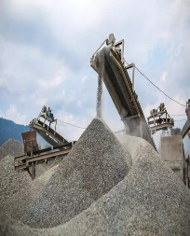

**Blended Cement**

Blended Cement is a type of cement that is produced by intergrading or blending Portland cement with supplementary cementitious materials (SCMs) such as fly ash, slag, silica fume, or limestone. These SCMs enhance the properties of the cement, making it more durable, sustainable, and cost-effective.

**Characteristics and Properties:**

1. **Enhanced Durability:** Blended cement offers improved resistance to chemical attacks, including sulphates and chlorides, which enhances the lifespan of concrete structures.
2. **Improved Workability:** The presence of SCMs can improve the workability and finish ability of the concrete mix.
3. **Reduced Heat of Hydration:** Blended cements typically generate less heat during the hydration process, reducing the risk of thermal cracking in large pours.
4. **Environmental Benefits:** The use of industrial by-products like fly ash and slag in blended cement reduces the carbon footprint and conserves natural resources.
5. **Cost-Effectiveness:** Blended cement can be more economical than pure Portland cement due to the use of cheaper SCMs.

**Types of Blended Cement:**

1. **Portland Pozzolana Cement (PPC):** Made by blending Portland cement with pozzolanic materials like fly ash.
2. **Portland Slag Cement (PSC):** Made by blending Portland cement with granulated blast furnace slag.
3. **Portland Limestone Cement (PLC):** Made by blending Portland cement with limestone.

**Applications:**

1. **General Construction:** Used in residential, commercial, and industrial buildings.
2. **Infrastructure Projects:** Ideal for roads, bridges, dams, and other large-scale infrastructure projects.
3. **Marine and Coastal Structures:** Suitable for structures exposed to seawater due to its enhanced durability.
4. **Environmental Structures:** Used in sewage treatment plants, wastewater treatment facilities, and other structures exposed to aggressive environments.

**Price Details of Blended Cement by Dalmia Cements**

Dalmia Cement is a leading manufacturer of blended cement in India, producing high-quality PPC, PSC, and PLC. The price of blended cement can vary based on factors such as the type of blend, region, market demand, and specific project requirements.

**General Price Range:**

* **Portland Pozzolana Cement (PPC):** Approximately INR 280 to INR 350 per 50 kg bag.
* **Portland Slag Cement (PSC):** Approximately INR 300 to INR 360 per 50 kg bag.
* **Portland Limestone Cement (PLC):** Approximately INR 290 to INR 340 per 50 kg bag.

# Outline of Customers and Suppliers:

1. IKN GMBH
2. REFRATECHNIK CEMENT GMBH
3. ARAMCO TRADING COMPANY
4. HONGKONG MINING MACHINERY IMPORT &
5. BENTLY NEVADA INC
6. GS TECHNOLOGY PTE LD
7. COOPER ROLLER BEARINGS CO. LTD
8. BROKK AB
9. POWER TOOLS DISTRIBUTION N V
10. INTERCEM ENGINEERING GMBH
11. LOESCHE
12. IKN GMBH
13. REFRATECHNIK GMBH
14. KRACHT GMBH
15. CHANDLER ENGINEERING COMPANY L.L.C
16. AUMUND FORDERTECHNIK GMBH & CO
17. FLOVEX S.P.A.
18. RICKMEIER GMBH
19. THERMO FISHER SCIENTIFIC (ECUBLENS)
20. HOTTINGER BALDWIN MESSTECHNIK GMBH
21. ABDULLA INTERNATIONAL (PVT) LTD.
22. SYNTRONICS LTD.,
23. BRICKING SOLUTIONS INC
24. HASLE REFRACTORIES A/S
25. SCHIESS-DEFRIES SYSTEMS GMBH
26. TATA INTERNATIONAL SINGAPORE
27. HORIBA LTD
28. SARTORIUS MECHATRONICS C & D
29. SHANGHAI EUTO MECHANICAL &
30. TD POWER SYSTEMS LTD.
31. TRANSFLUID S.R.L.
32. PRUFTECHNIK CONDITION MONITORING
33. TOTAL GAS & POWER ASIA PVT. LTD
34. SALES TAX OFFICE, LALGUDI
35. MISCELLANEOUS PARTIES
36. SOUTHERN RAILWAY
37. ELECTROTEK
38. KYORI OREMIN LTD.
39. GEBR Pfeiffer SE
40. Beumer Maschinenfabrik GmbH & Co. K
41. UNIVERSAL RESOURCES FZE
42. ADANI GLOBAL FZE
43. SHENYANG LANYING COLORED STEEL CO.,
44. MAGOTTEAUX S.A
45. RETSCH GMBH

# Implementation of Technology in Business:



**Introduction to SAP: Revolutionizing Corporate Business**

In the dynamic and ever-evolving landscape of modern corporate business, the ability to streamline operations, integrate processes, and leverage data for strategic decision-making is paramount. Enter SAP, or Systems, Applications, and Products in Data Processing, a powerhouse in enterprise resource planning (ERP) and business management software. With its origins dating back to 1972 in Germany, SAP has grown to become a global leader, transforming the way businesses operate across various industries.

**The Specialty of SAP in Real-World Corporate Business**

SAP's strength lies in its comprehensive and integrated suite of applications that cover virtually every aspect of business management. Here are some of the key specialties that set SAP apart in the corporate world:

1. **End-to-End Solution:** SAP provides an end-to-end suite of solutions that encompass financial management, human resources, supply chain management, customer relationship management, and more. This holistic approach ensures that all business processes are seamlessly connected and optimized.

2. **Real-Time Data Processing:** With SAP's HANA (High-Performance Analytic Appliance) technology, businesses can process vast amounts of data in real time. This capability enables instant insights and analytics, empowering companies to make data-driven decisions with agility and precision.

3. **Scalability and Flexibility:** SAP's solutions are designed to scale with the growth of a business. Whether it's a small enterprise or a large multinational corporation, SAP's modular structure allows businesses to implement and expand functionalities as needed.

4. **Industry-Specific Solutions:** SAP offers tailored solutions for various industries, including manufacturing, retail, healthcare, finance, and more. This specialization ensures that businesses can leverage industry best practices and achieve operational excellence.

5. **Global Reach and Support:** With a presence in over 180 countries and a robust support network, SAP is equipped to handle the complexities of global operations. Its multilingual and multicurrency capabilities make it an ideal choice for businesses operating across borders.

6. **Innovation and Continuous Improvement:** SAP invests heavily in research and development, continuously innovating its product offerings. From incorporating artificial intelligence and machine learning to enhancing user experiences with SAP Fiori, the company stays at the forefront of technological advancements.

**Difference Between SAP and Tally**

While Tally is a popular accounting software widely used by small and medium-sized businesses for financial management and bookkeeping, it is not on par with SAP when it comes to comprehensive business solutions. Here are some reasons why Tally cannot be compared to SAP:

1. **Scope and Scale:** Tally primarily focuses on accounting and financial management, whereas SAP offers a broad range of integrated business solutions that cover all major business functions.

2. **Customization and Flexibility:** SAP's modular architecture allows for extensive customization and flexibility, catering to the unique needs of various industries and business processes. Tally, on the other hand, has limited customization options.

3. **Real-Time Data and Analytics:** SAP's advanced data processing capabilities, particularly with SAP HANA, enable real-time data analysis and reporting. Tally lacks this level of sophistication in data analytics.

4. **Global Integration:** SAP supports complex global operations with its multilingual, multicurrency, and multinational functionalities. Tally is more suited to local or regional businesses with simpler operational requirements.

5. **Industry-Specific Solutions:** SAP provides tailored solutions for different industries, ensuring that businesses can leverage specific functionalities relevant to their sector. Tally does not offer such industry-specific customization.

In conclusion, SAP stands as a cornerstone of modern enterprise resource planning, offering unmatched capabilities that drive efficiency, innovation, and growth in the corporate world. Its comprehensive suite of solutions, real-time processing power, and global reach make it an indispensable tool for businesses aiming to thrive in a competitive environment. While Tally serves well for basic accounting needs, it cannot compete with the expansive, integrated, and advanced functionalities of SAP, which truly revolutionizes how businesses operate and succeed.

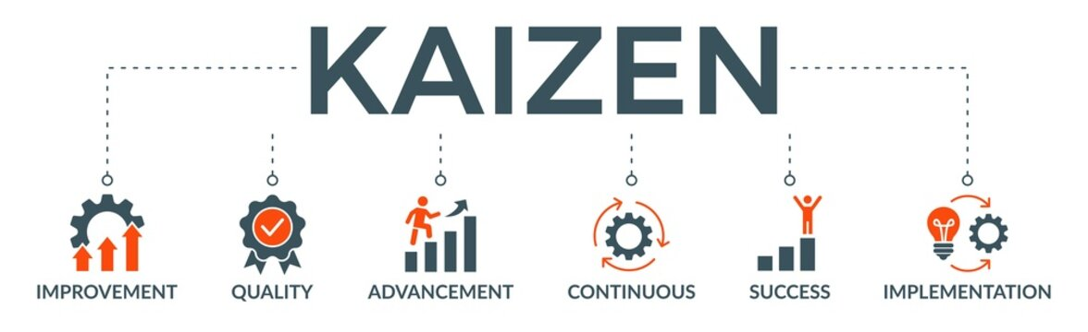

**Introduction to the Kaizen Method: Transforming Corporate Excellence**

In the relentless pursuit of operational excellence and continuous improvement, the Kaizen Method stands out as a beacon of transformative power. Originating from Japan, Kaizen, which translates to "change for better," embodies a philosophy that focuses on continuous, incremental improvements across all levels of an organization. Rooted in the manufacturing sector and famously implemented by Toyota, Kaizen has transcended industries and geographies to become a fundamental principle of modern corporate management.

**The Specialty of Kaizen in Real-World Corporate Business**

Kaizen's specialty lies in its ability to drive sustained growth and efficiency by fostering a culture of continuous improvement. Here are the key aspects that make Kaizen invaluable in the corporate world:

1. **Employee Empowerment:** At the heart of Kaizen is the belief that everyone, from top executives to frontline workers, plays a crucial role in the improvement process. By encouraging employees to suggest and implement improvements, Kaizen fosters a sense of ownership and accountability, leading to higher engagement and morale.

2**. Incremental Improvement:** Unlike radical change initiatives, Kaizen focuses on small, incremental changes that cumulatively lead to significant improvements. This approach reduces resistance to change and allows for continuous refinement and adaptation.

3. **Enhanced Efficiency and Productivity:** Kaizen emphasizes eliminating waste (muda), optimizing processes, and improving workflow. This results in enhanced operational efficiency, reduced costs, and increased productivity.

4. **Quality Improvement:** Through systematic problem-solving and root cause analysis, Kaizen drives improvements in product quality and service delivery. The emphasis on quality circles and continuous feedback ensures that high standards are maintained consistently.

5. **Sustainable Growth:** By embedding a culture of continuous improvement, organizations can adapt more effectively to changing market conditions, technological advancements, and customer demands. This adaptability ensures long-term sustainability and competitiveness.

6. **Holistic Approach:** Kaizen is not limited to production processes; it can be applied across all areas of a business, including administration, supply chain management, and customer service. This holistic approach ensures that improvement opportunities are identified and leveraged throughout the organization.

7**. Collaborative Culture:** Kaizen fosters collaboration and teamwork. Cross-functional teams work together to identify inefficiencies and develop solutions, breaking down silos and enhancing communication within the organization.

8. **Measurement and Accountability:** The Kaizen method relies on measurable outcomes and data-driven decision-making. Regular review and analysis of performance metrics ensure that improvements are tracked, and accountability is maintained.

**Real-World Applications of Kaizen**

1. **Manufacturing:** Companies like Toyota have revolutionized their production processes through Kaizen, achieving unprecedented levels of efficiency, quality, and innovation.

2. **Healthcare:** Hospitals and clinics use Kaizen to streamline operations, reduce wait times, and improve patient care.

3. **Retail:** Retailers apply Kaizen to enhance customer service, optimize inventory management, and improve store operations.

4. **IT and Technology:** Tech companies leverage Kaizen to enhance software development processes, improve product quality, and boost customer satisfaction.

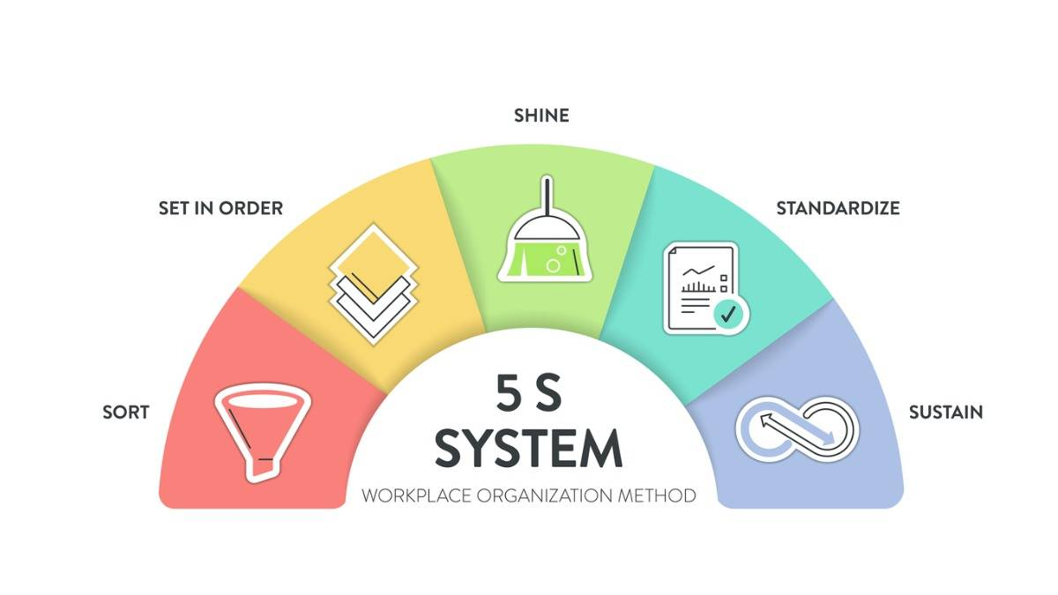

**Introduction to the 5S System: Streamlining Excellence in Corporate Business**

In the quest for operational efficiency and excellence, the 5S system stands out as a transformative methodology. Originating from Japan, the 5S system is a workplace organization method that uses a list of five Japanese words: Seiri, Seiton, Seiso, Seiketsu, and Shitsuke. These words translate to Sort, Set in Order, Shine, Standardize, and Sustain. The 5S system is designed to create a clean, organized, and efficient work environment, fostering productivity and quality across all levels of an organization.

**The Specialty of the 5S System in Real-World Corporate Business**

The 5S system's strength lies in its simplicity and effectiveness in creating a well-organized workplace that enhances productivity and reduces waste. Here are the key aspects that make the 5S system invaluable in the corporate world:

1. **Improved Efficiency**: By organizing the workplace and ensuring that everything has a designated place, the 5S system minimizes the time spent searching for tools, materials, or information. This leads to faster task completion and increased overall efficiency.

2. **Enhanced Safety**: A clean and well-organized workspace reduces the risk of accidents and injuries. By regularly cleaning and maintaining the workplace, potential hazards are identified and addressed promptly.

3. **Quality Improvement**: The systematic approach to organization and cleanliness helps in maintaining high standards of quality. By eliminating clutter and ensuring that equipment is well-maintained, the chances of errors and defects are reduced.

4. **Employee Engagement**: Involving employees in the 5S process fosters a sense of ownership and responsibility. When employees contribute to organizing their workspaces, they become more engaged and motivated, leading to higher morale and productivity.

5. **Cost Reduction**: By eliminating waste and optimizing the use of resources, the 5S system helps in reducing costs. This includes savings on materials, time, and space, which can be significant for any business.

6. **Sustainability**: The 5S system promotes a culture of continuous improvement and discipline. By sustaining the improvements through regular audits and reviews, organizations can ensure long-term benefits and adaptability to changes.

**Applications of the 5S System in Real-World Corporate Business**

1. **Manufacturing**: The 5S system is widely used in manufacturing to organize production lines, reduce waste, and improve product quality. It ensures that tools and materials are easily accessible, reducing downtime and enhancing productivity.

2. **Offices**: In office environments, the 5S system helps in organizing workstations, managing documents, and optimizing workflows. This results in a more efficient and pleasant work environment, improving employee satisfaction and productivity

3. **Healthcare**: Hospitals and clinics use the 5S system to maintain cleanliness, organize medical supplies, and streamline patient care processes. This leads to improved patient safety and service quality.

4. **Retail**: Retailers apply the 5S principles to maintain organized and attractive store layouts, manage inventory efficiently, and enhance the shopping experience for customers.

5. **Warehousing and Logistics**: The 5S system helps in organizing storage spaces, improving inventory management, and ensuring timely and accurate order fulfilment.

# Employee Welfare Benefit:

Dalmia Cement (Bharat) Limited is doing various Employee Welfare Benefit Activities the following are some of the Employee Welfare Activities with Images.

1)  

The Company is Providing Subsidised Accommodation for the Employees according to the Grade of the Employee for Bachelor Employees they give a Bachelor Staff Hostel, For Staff with Families they give Staff House, For Executives they Give Executive Grade House the first image is the Staff Hostel, the second image is the Manages Quarters.

2)  

The company is providing a Free Education to the Childrens of the Employee in their Own School (Dalmia Vidhya Mandir (DVM) – CBSE School) they have a dedicated School Ground Opposite to the School and Next to the Staff Hostel the first image is the School and the second images is the School Ground.

3) 

The company is having some recreation club for the employee and employee’s family the above image is one of the such club image.

4) 

The company is having 2 temples inside the Quarters the above photo is the representation of one of such temple.

# Awards and Achievements:

* CII-ITC Sustainability Awards
* GreenPro Certification
* Golden Peacock Environment Management Award
* National Award for Excellence in Energy Management
* CII Energy Efficiency Awards
* Frost & Sullivan and TERI Sustainability 4.0 Awards
* Social and Corporate Governance (SACG) Awards
* Golden Peacock Award for Corporate Social Responsibility
* Best Innovator in Manufacturing Award
* Digital Trailblazer Award
* CII-EXIM Bank Award for Business Excellence
* National Quality Award
* Safety Excellence Awards
* India CSR Leadership Awards
* Ethical Company of the Year Award
* CDP (Carbon Disclosure Project) India Climate Leader Award
* NSE (National Stock Exchange) Leadership in Sustainability Award
* Global Sustainability Leadership Award
* ICC (Indian Chamber of Commerce) Environment Excellence Award
* Quality Circle Forum of India (QCFI) Awards
* India CSR Awards
* ASSOCHAM CSR Excellence Award
* SAP ACE Award for Customer Excellence
* Golden Peacock Innovative Product/Service Award
* Institute of Directors (IOD) Golden Peacock Award for Quality
* Ramkrishna Bajaj National Quality Award
* National Safety Council Safety Awards
* British Safety Council Safety Award
* Golden Peacock Award for Corporate Governance
* Economic Times Iconic Brand Award
* National Award for Excellence in Renewable Energy
* SEEM National Energy Management Awards
* FICCI CSR Award
* TERI Sustainable Development Leadership Award
* Global Green Cement Award
* Energy Efficient Unit Award
* TPM Excellence Award
* Asia Responsible Enterprise Award
* National CSR Leadership Congress & Awards
* CII Industrial Innovation Award
* Rajiv Gandhi National Quality Award
* FICCI Quality Systems Excellence Award
* Cement Manufacturer of the Year
* Rural Development Leadership Award
* Inclusive Business Award

# Export Procedure and Documentation:

Dalmia Cement (Bharat) limited is exporting Cement products to Following Countries

* Sri Lanka
* Nepal
* Bangladesh
* Bhutan
* Myanmar
* UAE
* Oman
* Saudi
* African Countries
* Malasia
* Singapore

The companies major export is done to Sri Lanka and we can now see al the export procedure and documentation in detail

## Export Procedure:

Exporting goods, including cement, involves several steps that ensure compliance with legal requirements, efficient logistics, and successful delivery to international markets. Here’s a detailed procedure for exporting goods like cement:

**Market Research and Planning**

* Identify Target Markets: Conduct market research to identify countries with high demand for cement. Consider factors like economic growth, infrastructure projects, and regulatory environment.
* Market Entry Strategy: Decide on the mode of entry, such as direct exporting, through distributors, or joint ventures.

**Obtain Export Licenses and Permits**

* Regulatory Compliance: Ensure compliance with export regulations of the exporting country. Obtain necessary export licenses and permits from relevant authorities.
* Product Standards: Ensure the product meets the quality and regulatory standards of the target market. Obtain certifications if required.

**Pricing and Costing**

* Cost Calculation: Determine the cost of production, packaging, transportation, insurance, and tariffs.
* Pricing Strategy: Set competitive prices considering market conditions and cost factors. Include Incoterms (International Commercial Terms) to define responsibilities and costs between buyer and seller.

**Prepare Export Documentation**

* Commercial Invoice: An invoice detailing the products, quantity, price, and terms of sale.
* Bill of Lading: A document issued by the carrier acknowledging receipt of goods for shipment.
* Packing List: A detailed list of the contents of each package.
* Certificate of Origin: Certifies the country in which the goods were produced.
* Export License: If required, a license permitting the export of goods.
* Insurance Certificate: Proof of insurance coverage for the shipment.

**Arrange for Transportation and Logistics**

* Shipping Method: Decide on the most suitable mode of transportation (sea, air, or land) based on cost, time, and nature of goods.
* Freight Forwarder: Hire a freight forwarder to handle logistics, documentation, and transportation.
* Customs Clearance: Prepare and submit documents required for customs clearance in both exporting and importing countries.

**Packing and Labelling**

* Packaging: Ensure the cement is packed securely to prevent damage during transit. Use materials that comply with international shipping standards.
* Labelling: Label the packages with essential information such as handling instructions, destination address, and any regulatory markings.

**Export Financing and Payment**

* Payment Methods: Agree on payment terms with the buyer. Common methods include Letters of Credit (LC), advance payment, open account, or documentary collections.
* Export Financing: Consider financing options like export credit insurance, pre-shipment and post-shipment finance.

**Shipping and Delivery**

* Dispatch Goods: Ship the goods as per the agreed Incoterms and delivery schedule.
* Track Shipment: Monitor the shipment’s progress and provide updates to the buyer.

**Post-Delivery Activities**

* Customer Feedback: Follow up with the customer to ensure satisfaction and gather feedback for future improvements.
* After-Sales Service: Provide after-sales support and address any issues related to the shipment.

**Compliance and Record Keeping**

* Documentation: Maintain records of all export transactions, including contracts, invoices, shipping documents, and communications.
* Audit and Review: Periodically review export procedures and compliance with regulations. Conduct audits to ensure all processes are followed correctly.

**Conclusion – Export & Import Procedure**

Exporting cement involves a comprehensive procedure that requires meticulous planning, adherence to regulations, and efficient execution. By following these steps, exporters can ensure smooth and successful international transactions, thereby expanding their market reach and contributing to global trade.

# Corporate Social Responsibility (CSR):

The following are Some of the Main CSR Activities Done by Dalmia Cement (Bharat) Limited to the Wellness of the Society and Public.

1. **Healthcare and Sanitation:**
   1. Mobile health clinics providing free medical check-ups and treatment.
   2. Health camps focusing on specific health issues like diabetes, hypertension, and eye care.
   3. Installation of sanitation facilities to promote hygiene.
2. **Education:**
   1. Scholarships for underprivileged students.
   2. Infrastructure support to local schools, including construction of classrooms and provision of educational materials.
   3. Programs to enhance the quality of education through teacher training and e-learning initiatives.
3. **Livelihood and Skill Development:**
   1. Vocational training programs to enhance employability skills among the local youth.
   2. Support for women’s self-help groups to promote entrepreneurship and self-reliance.
   3. Agricultural training programs to improve productivity and sustainability for local farmers.
4. **Environment:**
   1. Tree plantation drives to enhance green cover and promote biodiversity.
   2. Water conservation projects including the construction of check dams and rainwater harvesting systems.
   3. Initiatives to reduce carbon footprint and promote renewable energy.
5. **Community Development:**
   1. Development of infrastructure like roads, community centers, and other public amenities.
   2. Support for local cultural and sports activities to foster community spirit and well-being.
   3. Disaster relief and rehabilitation assistance during natural calamities.

# SWOT Analysis:

**Weakness**

* Inefficient use of shareholder funds - ROE declining in the last 2 years
* Inefficient use of assets to generate profits - ROA declining in the last 2 years
* Annual net profit declining for last 2 years
* Near 52 Week Low
* Weak Momentum: Price below Short-, Medium- and Long-Term Averages

**Strength**

* Growth in Net Profit with increasing Profit Margin (QoQ)
* Company with Low Debt
* Increasing Revenue every quarter for the past 2 quarters
* Increasing profits every quarter for the past 2 quarters
* Strong cash generating ability from core business - Improving Cash Flow from operation for last 2 years
* Company able to generate Net Cash - Improving Net Cash Flow for last 2 years
* Company with Zero Promoter Pledge

**Threats**

* High PE
* Increasing Trends in Non-Core Income
* RSI indicating Price Weakness
* Brokers Has reduced Their Recommendation Price

**Opportunity**

* Brokers Upgraded Recommendations or Target Price in past Three Months.
* High Analyst Rating with at least 20% upside.
* New Specialised Application.
* Profit Margin is Good

# Questioner:

Are You Satisfied with the Company?



How long have you been working at Dalmia Cement?



What factors influence your decision to stay or leave your current role? (Select all that apply)



How effective do you find the current employee retention strategies at Dalmia Cement?



What specific retention strategies do you believe are most impactful? (Select all that apply)



How satisfied are you with the level of recognition and appreciation you receive at Dalmia Cement?



How transparent do you find communication regarding career opportunities within Dalmia Cement?



How satisfied are you with the work environment and culture at Dalmia Cement?



How important is work-life balance to you in your decision to stay with Dalmia Cement?



How satisfied are you with the training and development opportunities provided by Dalmia Cement?



How supported do you feel by your manager in your professional growth and development?



Are you provided with adequate resources and tools to perform your job effectively?



Have you experienced any opportunities for career advancement since joining the company?



How satisfied are you with the support provided by your immediate supervisor or manager?



# Conclusion of the Report;

Dalmia Cement (Bharat) Limited (DCBL), a prominent player in the Indian cement industry, has demonstrated robust growth and a strong commitment to sustainability, innovation, and corporate social responsibility. This conclusion synthesizes the key findings from the comprehensive analysis of DCBL's operations, market position, financial health, sustainability initiatives, and future prospects.

**Market Position and Competitive Advantage**

DCBL has established a formidable market position through strategic capacity expansions, acquisitions, and a strong distribution network. Its diverse product portfolio, catering to various segments such as residential, commercial, and infrastructure, has enabled the company to meet the dynamic demands of the market. The company's emphasis on quality, coupled with its customer-centric approach, has fortified its brand reputation and customer loyalty.

**Financial Performance**

The financial analysis reveals that DCBL has consistently delivered strong financial performance, characterized by steady revenue growth, healthy profit margins, and robust cash flows. The company's prudent cost management strategies and operational efficiencies have contributed significantly to its profitability. Additionally, DCBL's strong balance sheet and low debt levels provide it with the financial flexibility to invest in growth opportunities and withstand economic downturns.

**Sustainability and Environmental Stewardship**

DCBL's commitment to sustainability is evident through its ambitious goals to achieve carbon negativity by 2040 and its proactive measures in reducing carbon emissions. The company has invested in alternative fuels, renewable energy, and energy-efficient technologies, setting benchmarks in the industry for environmental stewardship. Furthermore, DCBL's initiatives in water conservation, waste management, and biodiversity preservation underscore its holistic approach to sustainability.

**Innovation and Technological Advancements**

Innovation is a cornerstone of DCBL's strategy, with significant investments in research and development to enhance product quality and operational efficiency. The adoption of advanced technologies such as AI, IoT, and blockchain in its manufacturing processes has streamlined operations, reduced costs, and improved product consistency. DCBL's focus on digital transformation positions it well to leverage Industry 4.0 advancements and maintain a competitive edge.

**Corporate Social Responsibility (CSR)**

DCBL's CSR initiatives reflect its deep-rooted commitment to social welfare and community development. The company has undertaken numerous projects in education, healthcare, rural development, and livelihood enhancement, positively impacting the lives of millions. DCBL's efforts in promoting inclusive growth and social equity resonate with its vision of being a responsible corporate citizen.

**Challenges and Risk Mitigation**

Despite its strong market position, DCBL faces challenges such as fluctuating raw material prices, regulatory changes, and intense competition. However, the company's proactive risk management framework, diversification strategies, and focus on operational excellence mitigate these risks effectively. DCBL's strategic partnerships and collaborations further enhance its resilience and adaptability in a dynamic business environment.

**Future Prospects**

Looking ahead, DCBL is well-positioned to capitalize on the growth opportunities in the Indian cement sector, driven by the government's infrastructure development initiatives and urbanization trends. The company's ongoing capacity expansions, focus on sustainable practices, and technological advancements will play a crucial role in sustaining its growth trajectory. Moreover, DCBL's commitment to innovation and customer satisfaction will continue to drive its competitive advantage.

# Annual Report:



The company result published in 2024 is better than the result published in 2023 and shows a continues improvement in the business they have Rs. 3,382 crores working capital which is 17.02% higher than the previous year which is a better indication a good sign for the company not only in this year the total working capital is keep on increasing YoY. When we see the working capital cycle it is 4 days for the year 2024 which is 87.44% lesser than in 2023 as the working capital cycle is increased in 2023 by 2.68% while comparing to the year 2022. one of the negative points in this is inventory holding period and Receivable collection Period has increased but a good point is the payables payment period is also increased to 206.29% while compared to the last year. When we come to the EPS side see a downfall of 20.23% while compared to the last year the ROE and ROA has been Reduced to 24.02% and 26.67% respectively. Other than these all-other ratios are showing a good sign while compared to the past year. From the all-other data, we can see that the company is over capitalised when we see the liquidity part. The reserves and Surplus have raised to 5.01% when compared to the last year. Apart from all these the company is floating in liquidity so there will be no liquidity problem in the company but in the same manner the company is raising a huge working capital which is 847 crores to 3,382 crores in last 5 years. The shareholder fund also raised to 4.92% while comparing to the last year. The short-term borrowing also reduced to 62.59% and 55.69% in the years 2024 and 2023 respectively.



The company’s financial ratios are doing good when we see the Gross profit margin, Operating Profit Margin, Net Profit Margin have raised to 10.93%, 16.86, 49.87% respectively and ROCE, Current Ratio, and Quick ratio also done good when we see the P/E Ratios and Debt to Equity Ratios we can see a reduction in growth of the ratios. So, we can say that the profitability ratio is doing good when we see to the investor return ratio like Basic EPS and Diluted EPS has reduced to 20.23% and 20.22% respectively ROE and ROA have reduced to 24.02% and 26.67% respectively. So, we can come to a conclusion as the company is highly concentrated on Liquidity but when we see the return except ROCE all other ratios are showing a Negative result. To increase that if the company is having a master plan like investing in Greenfield investment, then it is not a problem.

# Case Study for Dalmia Cement:

**Introduction:** Dalmia Cement (Bharat) Limited, a leading Indian cement manufacturer, was founded in 1939 by Jaidayal Dalmia. It is a part of the Dalmia Bharat Group, which has diverse business interests, including cement, sugar, and refractories. The company has a strong presence in southern, eastern, and northeastern India with a significant market share.

**Problem Statement:** In the early 2000s, Dalmia Cement faced several challenges:

1. **Intense Competition:** The Indian cement industry was highly competitive, with major players like UltraTech, ACC, and Ambuja dominating the market.
2. **Rising Costs:** The cost of raw materials, energy, and logistics was increasing, squeezing profit margins.
3. **Environmental Concerns:** Increasing regulatory pressure to reduce carbon emissions and adopt sustainable practices.

**Strategic Initiatives:**

1. **Capacity Expansion and Modernization:**
   * Dalmia Cement undertook a significant capacity expansion, increasing its production capacity to over 30 million tonnes per annum (MTPA).
   * Investment in modernizing existing plants to improve efficiency and reduce costs.
2. **Geographic Diversification:**
   * Expanded its footprint in the northeastern region of India through acquisitions and setting up new plants.
   * Entry into new markets to reduce dependency on traditional markets in the southern and eastern regions.
3. **Sustainability and Innovation:**
   * Focus on producing blended cement, which is more environmentally friendly.
   * Adoption of alternative fuels and raw materials (AFR) to reduce reliance on traditional fossil fuels.
   * Implementation of waste heat recovery systems (WHRS) to generate electricity from waste heat.
4. **Operational Excellence:**
   * Introduction of advanced technologies and automation to enhance productivity.
   * Optimization of the supply chain to reduce logistics costs.
   * Emphasis on training and development to improve workforce efficiency.

**Outcomes:**

1. **Financial Performance:**
   * Significant improvement in revenue and profitability.
   * Enhanced shareholder value through better returns on investment.
2. **Market Position:**
   * Strengthened position in the northeastern market, becoming one of the top players.
   * Increased market share in existing markets through competitive pricing and superior product quality.
3. **Sustainability Achievements:**
   * Reduction in carbon footprint through increased use of blended cement and AFR.
   * Recognition and awards for sustainability initiatives and environmental management.
4. **Operational Efficiency:**
   * Improved energy efficiency and reduced operational costs.
   * Higher employee productivity and satisfaction due to better training and working conditions.

**Challenges and Lessons Learned:**

1. **Managing Growth:**
   * Rapid expansion posed challenges in maintaining consistent product quality and operational efficiency.
   * Need for robust management practices and strong leadership to navigate the complexities of a growing business.
2. **Regulatory Compliance:**
   * Constantly evolving environmental regulations required ongoing investments in sustainability measures.
   * Proactive engagement with regulatory bodies to stay ahead of compliance requirements.
3. **Innovation and Adaptability:**
   * Importance of continuous innovation in products and processes to stay competitive.
   * Flexibility to adapt to changing market dynamics and customer preferences.

**Conclusion:** Dalmia Cement's strategic initiatives in capacity expansion, geographic diversification, sustainability, and operational excellence have enabled it to overcome industry challenges and achieve significant growth. The company's focus on innovation and sustainability has not only improved its financial performance but also established it as a leader in environmentally responsible manufacturing. The case of Dalmia Cement illustrates the importance of a multifaceted approach in navigating a competitive and dynamic industry landscape.

# Conclusion:

Dalmia Cement exemplifies industry leadership through its strategic vision, robust organizational structure, and innovative product offerings. Positioned for growth in a burgeoning cement industry, the company leverages advanced technology and a strong supplier-customer network to maintain its competitive edge.

Key departments collaborate efficiently to drive quality and customer satisfaction, while comprehensive employee welfare measures and impactful CSR initiatives highlight its commitment to sustainable development. The company's numerous awards and solid financial performance underscore its operational excellence and market strength.

In summary, Dalmia Cement's dedication to innovation, sustainability, and community welfare ensures its continued success and influential presence in the cement industry.

# Snap Shot:.





















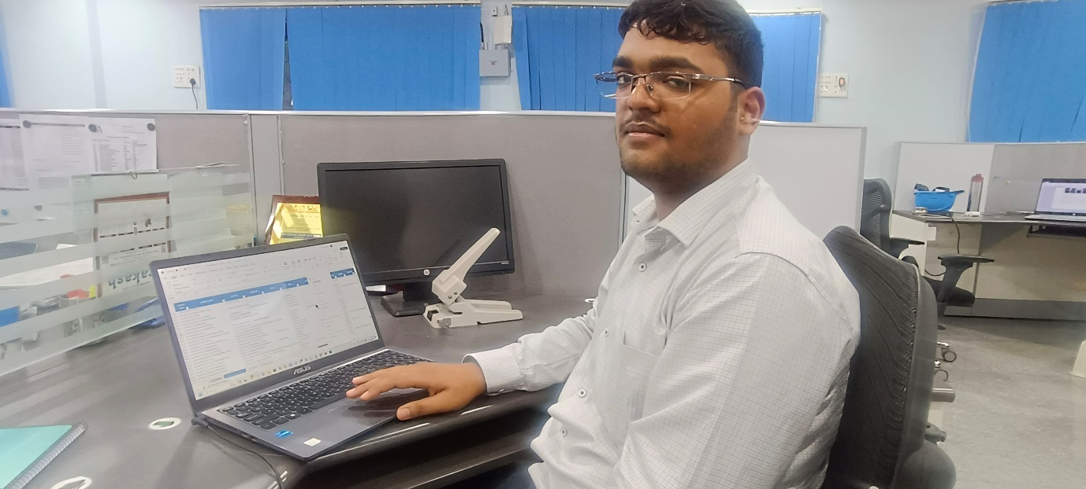

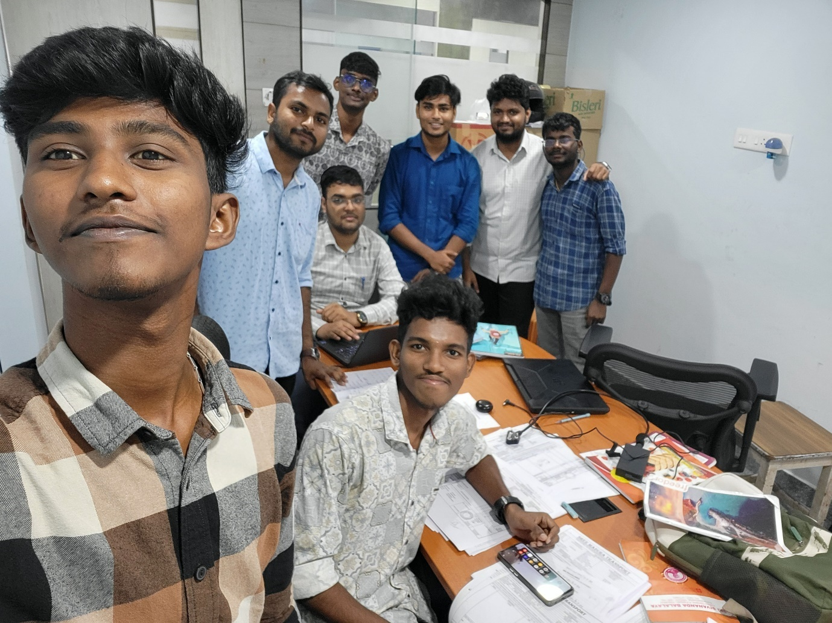

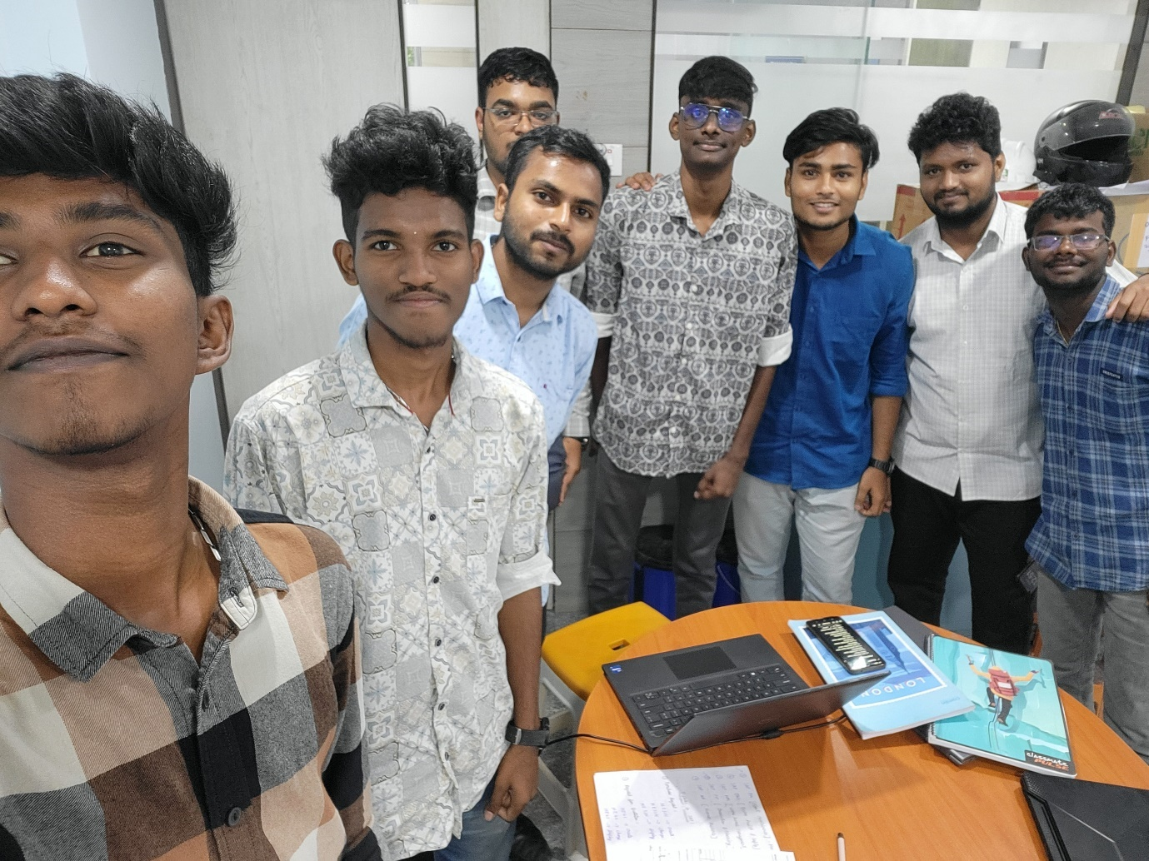

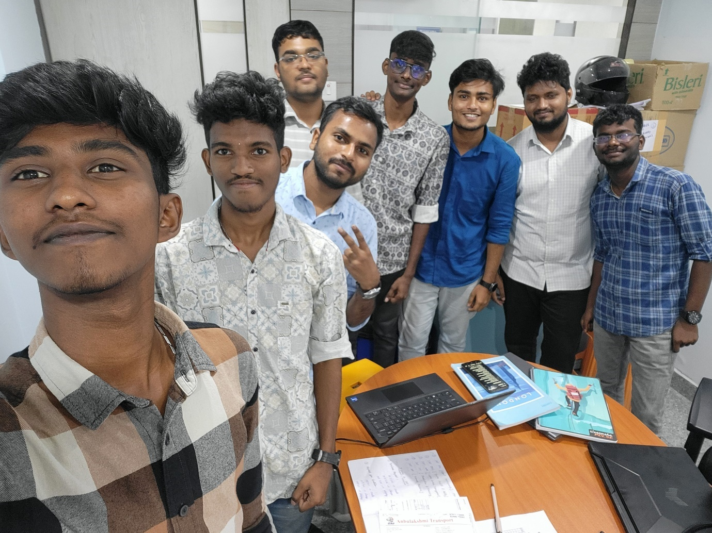



 Stage II - VIJAY ANANDH.A - to

# Student name

VIJAY ANANDH.A

**Student email** vijayanandha22baf157@skasc.ac.in

**Student contact no.**

9444234510

**Project**

A Report on Innovative Production of Dalmia Cement (Bharat) Limited

# Company

Dalmia Cement (Bharat) Limited , Dalmiapuram, Trichy **Company website** [https://www.dalmiacement.com/ (https://www.dalmiacement.com/)](https://www.dalmiacement.com/)

# Company Guide

M.Desingu , m.desingu@dalmiacement.com **College Guide**

KUMARASAMY T , kumarasamyt@skasc.ac.in

# Duration

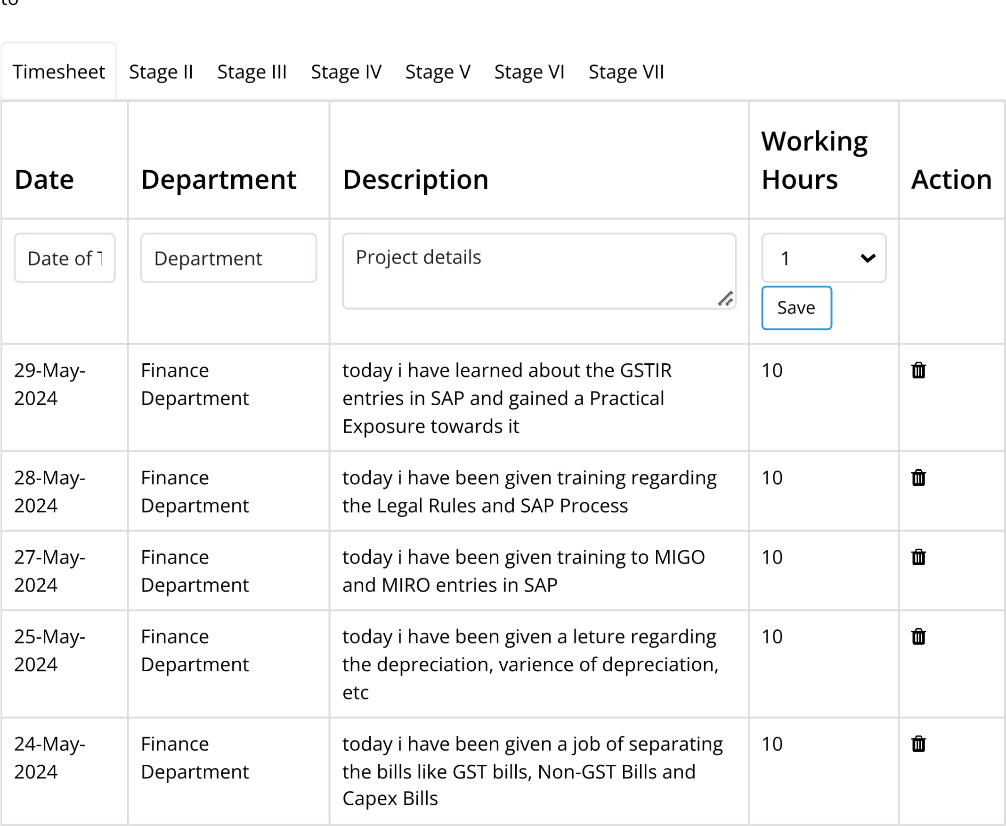

|  |  |  |  |  |
| --- | --- | --- | --- | --- |
| **Date** | **Department** | **Description** | **Working**  **Hours** | **Action** |
| 23-May-  2024 | Finance  Department | Today I have been trained with all the Acts regarding to the Labours like PF and  Companies Act | 10 |  |
| 22-May-  2024 | Finance  Department | My Trainer Gave a Career Guidance  Training for me | 8 |  |
| 21-May-  2024 | Finance  Department | today i have given training to the newly joined trainees for their higher studies using the PPT i created Earlier | 10 |  |
| 20-May-  2024 | Finance  Department | today i have been given a job of entering the  Stores and Spares Entries in SAP with  Proper Guidance | 10 |  |
| 18-May-  2024 | Finance  Department | i have been given an opportunity to see the payment Entries using the F-53 T-code | 10 |  |
| 17-May-  2024 | Finance  Department | today i have been given training to book all the real bills regarding to the company | 10 |  |
| 16-May-  2024 | Finance  Department | today i have been given a detailed understanding about the T-codes  Like F denotes nance and M denotes Material Management | 10 |  |
| 15-May-  2024 | Finance  Department | Today i have trained all the trainees regarding the T-codes with the real Bills | 10 |  |
| 14-May-  2024 | Production  Department | i have been taken to the plant Visit in that i got a real picture of how they manufacture a Cement | 10 |  |
| 13-May-  2024 | Finance  Department | i have Presented the T-Codes I Know to the newly Joined Trainee with Practical  Experience | 10 |  |
| 11-May-  2024 | Finance  Department | For the Excel Created yesterday i have created a Book Chapter in Word For SAP and Its T-Codes | 10 |  |
| 10-May-  2024 | Finance  Department | for the work done yesterday i have created a Excel consisting of 117 T-Codes used in  SAP with all the details regarding to  Finance Department | 10 |  |
| 9-May-  2024 | Finance  Department | I have Created PPT For the Topic Covering all the T-Codes Used in SAP by the Finance  Department | 10 |  |
| **Date** | **Department** | **Description** | **Working**  **Hours** | **Action** |
| 8-May-  2024 | Finance  Department | i have created a PPT for the Upcoming New Trainees Regarding the Higher Studies after  B.Com | 10 |  |
| 7-May-  2024 | Finance  Department | Veri cation of documents and entering it in excel | 10 |  |
| 6-May-  2024 | Finance  Department | Veri cation of documents and entering it in excel | 10 |  |
| 4-May-  2024 | Finance  Department | Overviewing of operations | 8 |  |
| 3-May-  2024 | Finance  Department | Verification and sorting of data | 9 |  |
| 2-May-  2024 | Finance  Department | Contract verification and data entry for ariyalur branch, Bank Reconciliation  Statement, Expense Entry and Validation in  SAP | 10 |  |
| 1-May-  2024 | Finance  Department | Veri cation of TDS Amount and Posting it on Excel, Contract verification and data entry for Dalmiapuram Branch | 10 |  |
| 30-Apr-  2024 | Finance  Department | Legal Proceedings Related to TDS and GST,  Practical Training on Bill Booking | 8 |  |
| 29-Apr-  2024 | Finance  Department | Safety Induction, introduction to company and their process, Introduction to their accounting software and explanation of T-  Codes in SAP | 8 |  |

2014-24 © [MyKlassroom.com 4.0 (/)](https://www.myklassroom.com/) Powered by [MyKlassroom.com (/)](https://www.myklassroom.com/)

 Stage II - VIJAY ANANDH.A - to

**Student name**

VIJAY ANANDH.A **Student email**

vijayanandha22baf157@skasc.ac.in **Student contact no.**

9444234510

**Project**

A Report on Innovative Production of Dalmia Cement (Bharat) Limited

**Company**

Dalmia Cement (Bharat) Limited , Dalmiapuram, Trichy **Company website**

[https://www.dalmiacement.com/ (https://www.dalmiacement.com/)](https://www.dalmiacement.com/)

**Company Guide**

M.Desingu , m.desingu@dalmiacement.com **College Guide**

KUMARASAMY T , kumarasamyt@skasc.ac.in **Duration** to

Timesheet Stage II Stage III Stage IV Stage V Stage VI Stage VII

**Organisational Structure / Project Name (Students doing in Production company - mention the organisation structure; For those doing project for the company - mention the project title)**

Industrial Exposure Training done at Dalmia Cement (Bharat) Limited, Dalmiapuram

**No of workers in the organisation / Nature of project inputs**

5642

**Products from the organisation / Inputs for the project**

Cement production

**Activities Planned in the first week - Short title**

Induction, legal rules relating to TDS and GST, Accounting Software, bill booking, contract verifications,

Bank Reconciliation Statement, data entry in SAP, verification and sorting of data and overview of the

**Nature of work executed in the first week / Details of Data gathered in the first week**

Data Entry, Verfication, Sorting

**Mention the mile stones of the organisation / Project specification**

the company has no milestone as they have a clear structure to move on in the eld and has a huge number of customers in India

Powered by

MyKlassroom.co

[m](https://www.myklassroom.com/)

(/

[)](https://www.myklassroom.com/)

2014-24

©

MyKlassroom.com 4.

[0](https://www.myklassroom.com/)

[(](https://www.myklassroom.com/)

[/](https://www.myklassroom.com/)

[)](https://www.myklassroom.com/)

**Any other remarks**

Overall the company is highly statifying me they are very friendly and tecahing me in each and every corner of

the company procedure and advising for my carrear plan also

Submit

 Stage II - VIJAY ANANDH.A - to

# Student name

VIJAY ANANDH.A **Student email**

vijayanandha22baf157@skasc.ac.in **Student contact no.**

9444234510

**Project**

A Report on Innovative Production of Dalmia Cement (Bharat) Limited

# Company

Dalmia Cement (Bharat) Limited , Dalmiapuram, Trichy **Company website**

[https://www.dalmiacement.com/ (https://www.dalmiacement.com/)](https://www.dalmiacement.com/)

# Company Guide

M.Desingu , m.desingu@dalmiacement.com **College Guide**

KUMARASAMY T , kumarasamyt@skasc.ac.in

# Duration

to

**The Process (in the respective department)**

**Nature of Work/service (JIT/POP/Service Delivery)**

Accounts Preparation, veri cation, Accounts receivable management and Accounts payable management

**Job Scheduling system (mention in 4 steps)**

Timesheet

Stage II

Stage III

Stage IV

Stage V

Stage VI

Stage VII

1. first they are giving the Introduction to their company process and the accounting software they are using
2. they gave a practical training on the accounting software
3. General rules regarding the TDS and GST
4. Data Entry and sorting of data

# Work ow/ Data ow/ Process ow - Mention in a diagram

1)

Limestone Extraction

2)

Crusher

3)

Raw Mill

4)

Clinker

5)

CVRM ( Cement Vertical Roller

)

6)

SIlo

7)

Packaging

Purchase request - Request for quatation - price comparision - purchaing order goods receipt

# Work / Service Delivery system - Mention in 100 words

Powered by

[m](https://www.myklassroom.com/)

MyKlassroom.co

[)](https://www.myklassroom.com/)

(/

2014-24

©

[0](https://www.myklassroom.com/)

MyKlassroom.com 4.

[/](https://www.myklassroom.com/)

[(](https://www.myklassroom.com/)

[)](https://www.myklassroom.com/)

A work system for a cement manufacturing company like Dalmia Cement would involve the integration of

various aspects of operations to ensure e

ciency, safety, and productivity. Below are key components

that make up a comprehensive work system for such a company:

Production Management:

cient procurement, transportation, and storage of raw materials such as

Raw Material Handling: E

limestone, clay, and gypsum.

Manufacturing Process: Optimized processes including crushing, grinding, mixing, clinker production, and

cement grinding.

Quality Control: Regular testing and monitoring of the production process to ensure quality standards are

met

Submit

 Stage II - VIJAY ANANDH.A - to

# Student name

VIJAY ANANDH.A **Student email**

vijayanandha22baf157@skasc.ac.in **Student contact no.**

9444234510

**Project**

A Report on Innovative Production of Dalmia Cement (Bharat) Limited

# Company

Dalmia Cement (Bharat) Limited , Dalmiapuram, Trichy **Company website**

[https://www.dalmiacement.com/ (https://www.dalmiacement.com/)](https://www.dalmiacement.com/)

# Company Guide

M.Desingu , m.desingu@dalmiacement.com **College Guide**

KUMARASAMY T , kumarasamyt@skasc.ac.in

# Duration

TDS,GST,BRS,SAP,BIll Booking

to

**The Discussions/ Project Assigned**

**Title**

Veri cation, data entry, sorting, BRS and Bill Booking

**Workforce (Individual/Group)**

Timesheet

Stage II

Stage III

Stage IV

Stage V

Stage VI

Stage VII

The workforce of Dalmia Cement is a critical component of its operations, covering a range of roles and responsibilities across different areas of the business. In production and operations, the workforce includes production managers, machine operators, quality control technicians, and maintenance technicians who ensure efficient manufacturing processes. Engineering and technical sta such as process engineers, electrical and mechanical engineers, and civil engineers optimize operations and maintain the plant's infrastructure.

# Feasibliity (Mention in 150 words)

The feasibility of Dalmia Cement as a cement manufacturing company is strong, given its established presence in the industry and reputation for producing high-quality cement. The company bene ts from a well-developed supply chain, experienced workforce, and modern production facilities, ensuring efficient operations and consistent product quality. Dalmia Cement's focus on sustainable practices and adherence to environmental regulations position it favourably in a market increasingly conscious of eco-friendly products and practices.

The company's strong distribution network and marketing strategies help maintain its competitive edge in

**Concepts in the discussion/ project (Mention in 100 words)**

# Viability/ Aim/Purpose ( Mention in 100 words)

Dalmia Cement is a viable cement manufacturing company due to its strong market presence and reputation for quality products. Its efficient supply chain, modern production facilities, and experienced workforce support consistent operations. The company's commitment to sustainability and adherence to environmental standards align with market trends favouring eco-friendly practices.

Dalmia Cement's robust distribution network and marketing strategies ensure a competitive edge. Investments in technology and innovation help maintain efficiency and adapt to market changes. Potential risks include raw material cost actuations and regulatory shifts, which the company manages through

Submit

2014-24 © [MyKlassroom.com 4.0 (/)](https://www.myklassroom.com/) Powered by [MyKlassroom.com (/)](https://www.myklassroom.com/)

 Stage II - VIJAY ANANDH.A - to

# Student name

VIJAY ANANDH.A **Student email**

vijayanandha22baf157@skasc.ac.in **Student contact no.**

9444234510

**Project**

A Report on Innovative Production of Dalmia Cement (Bharat) Limited

# Company

Dalmia Cement (Bharat) Limited , Dalmiapuram, Trichy **Company website**

[https://www.dalmiacement.com/ (https://www.dalmiacement.com/)](https://www.dalmiacement.com/)

# Company Guide

M.Desingu , m.desingu@dalmiacement.com **College Guide**

KUMARASAMY T , kumarasamyt@skasc.ac.in **Duration** to

Timesheet Stage II Stage III Stage IV Stage V Stage VI Stage VII

# The Data Analytics / Annual Reports Name of the reports/ documents gone through (Mention along with purpose)

The company result published in 2024 is better than the result published in 2023 and shows a continues improvement in the business they have Rs. 3,382 crores working capital which is 17.02% higher than the previous year which is a better indication a good sign for the company not only in this year the total working capital is keep on increasing YoY. When we see the working capital cycle it is 4 days for the year 2024 which is 87.44% lesser than in 2023 as the working capital cycle is increased in 2023 by 2.68% while comparing to the year 2022. one of the negative points in this is inventory holding period and Receivable

# Referral Points from the Reports/ Data (Mention any 5)

The company’s financial ratios are doing good when we see the Gross pro t margin, Operating Pro t

Margin, Net Pro t Margin have raised to 10.93%, 16.86, 49.87% respectively and ROCE, Current Ratio, and Quick ratio also done good when we see the P/E Ratios and Debt to Equity Ratios we can see a reduction in growth of the ratios. So, we can say that the prorfiability ratio is doing good when we see to the investor return ratio like Basic EPS and Diluted EPS has reduced to 20.23% and 20.22% respectively ROE and ROA h d d 24 02% d 26 67%

# IPO Design/ Concurrence/Deviation in data processing (mention in 150 words)

Designing an IPO for Dalmia Cement involves rigorous market research, internal audits, and ensuring regulatory compliance with SEBI. Key steps include pricing strategy, share allocation, and prospectus preparation.

For concurrence in data processing, maintaining data integrity through accurate record-keeping, audit trails, and validation checks is crucial. Coordination among internal departments and external stakeholders, alongside timely regulatory submissions and ongoing disclosures, ensures alignment.

Managing deviations involves continuous data monitoring to detect anomalies conducting root cause

2014-24 © [MyKlassroom.com 4.0 (/)](https://www.myklassroom.com/) Powered by [MyKlassroom.com (/)](https://www.myklassroom.com/)

 Stage II - VIJAY ANANDH.A - to

# Student name

VIJAY ANANDH.A **Student email**

vijayanandha22baf157@skasc.ac.in **Student contact no.**

9444234510

**Project**

A Report on Innovative Production of Dalmia Cement (Bharat) Limited

# Company

Dalmia Cement (Bharat) Limited , Dalmiapuram, Trichy **Company website**

[https://www.dalmiacement.com/ (https://www.dalmiacement.com/)](https://www.dalmiacement.com/)

# Company Guide

M.Desingu , m.desingu@dalmiacement.com **College Guide**

KUMARASAMY T , kumarasamyt@skasc.ac.in **Duration** to

Timesheet Stage II Stage III Stage IV Stage V Stage VI Stage VII

# The USP of the rm/ work simulation The Brand name (of product/service)

1)Extensive and Expanding Capacity: Dalmia Cement is one of the largest producers of cement in India, with a projected capacity of approximately 56 million tons per annum by the end of FY 2024. This significant capacity is supported by both organic growth and strategic acquisitions, such as the acquisition of JPA's cement and power businesses, which will add an additional 9.4 million tons to its portfolio. 2)Operational Efficiency and Cost Management: The company has demonstrated exceptional operational performance by e effctively managing its power and fuel expenses. This efficiency has allowed Dalmia Cement to maintain healthy operating margins despite a competitive pricing environment. The decline in international and domestic fuel prices has further enhanced its operational profitability.

# The event/Cross cultural Relationship/ Constraints

Cross-Cultural Relationships

a. Investor Relations:

Global Investors: Engaging with international investors necessitates understanding diverse nancial

cultures, investment preferences, and regulatory environments.

Communication Strategies: Tailoring communication to suit cultural contexts, using language and

channels appropriate for di erent regions.

b. Employee Engagement:

Diverse Workforce: Ensuring that employees from various cultural backgrounds are aligned with the IPO’s

goals and processes.

Inclusive Policies: Implementing inclusive policies and practices that respect cultural di erences and

promote a cohesive work environment.

c

Customer

and

Supplier

Relations:

**What you considered as the USP?**

This USP effectively highlights Dalmia Cement’s strengths in capacity, operational efficiency, sustainability, market positioning, and financial robustness.

# Justify your answer in 200 words

The Unique Selling Proposition (USP) for Dalmia Cement is compelling due to several strategic strengths that position the company favourably in the market. Firstly, the extensive and expanding capacity highlights Dalmia Cement’s ability to scale and meet increasing demand. A projected capacity of 56 million tons per annum by FY 2024, bolstered by strategic acquisitions like JPA’s cement and power businesses, demonstrates robust growth and competitive edge.

# Any other point you are considering as USP? If yes mention

1. Sustainability and Innovation:

As a leader in sustainable practices, Dalmia Cement has significantly reduced its carbon footprint and adopted eco-friendly manufacturing processes. This commitment appeals to eco-conscious consumers and investors, aligning with global environmental standards.

1. Strategic Market Positioning:

With a strong presence across various Indian regions, Dalmia Cement benefits from a diverse market base. This geographic diversification mitigates regional demand fluctuations and enhances market resilience, supported by high-demand areas and government infrastructure projects.

1. Financial Strength and Investment Appeal:

Despite market volatilities Dalmia Cement’s strong financial performance and growth potential make it an

Submit

2014-24 © [MyKlassroom.com 4.0 (/)](https://www.myklassroom.com/) Powered by [MyKlassroom.com (/)](https://www.myklassroom.com/)

 Stage II - VIJAY ANANDH.A - to

# Student name

VIJAY ANANDH.A **Student email**

vijayanandha22baf157@skasc.ac.in **Student contact no.**

9444234510

**Project**

A Report on Innovative Production of Dalmia Cement (Bharat) Limited

# Company

Dalmia Cement (Bharat) Limited , Dalmiapuram, Trichy **Company website**

[https://www.dalmiacement.com/ (https://www.dalmiacement.com/)](https://www.dalmiacement.com/)

# Company Guide

M.Desingu , m.desingu@dalmiacement.com **College Guide**

KUMARASAMY T , kumarasamyt@skasc.ac.in **Duration** to

Timesheet Stage II Stage III Stage IV Stage V Stage VI Stage VII

# The Value Stream/ output/ Mention the value proposition of your training in 200 words

The Industrial Exposure Training at Dalmia Cement o ers a unique and comprehensive learning experience, designed to provide participants with in-depth insights into the cement industry. Over the course of one month, trainees will gain hands-on experience and practical knowledge, making this training invaluable for their professional growth.

1. In-Depth Industry Knowledge:

Participants will be exposed to the entire value stream of cement production, from raw material procurement to nal product delivery. This holistic understanding equips trainees with a thorough grasp of industry operations and best practices.

1. Operational Excellence:

# Your ndings (that will enrich your knowledge) 150 words

Dalmia Cement, a leader in the Indian cement industry, operates with a substantial production capacity projected to reach 56 million tons annually by FY 2024. This expansion is fueled by both organic growth and strategic acquisitions, such as JPA's cement and power businesses. Known for operational excellence, Dalmia Cement maintains healthy margins through e ective power and fuel management, bene ting further from declining fuel prices.

The company’s commitment to sustainability is evident in its signi cant reduction of carbon footprints and eco-friendly manufacturing processes. This not only meets global environmental standards but also attracts eco-conscious consumers and investors. Dalmia Cement’s diverse geographical presence across India helps mitigate regional demand ct ations and strengthens market resilience

# Domain Knowledge (Gained) - Mention in 100 words

The nance department of Dalmia Cement is pivotal in ensuring the company's robust nancial health and strategic growth. It oversees nancial planning, budgeting, and cost management, ensuring e cient allocation of resources. The department is adept at managing operational costs, particularly in power and fuel expenses, contributing to healthy pro t margins. It also handles regulatory compliance, investor relations, and nancial reporting, ensuring transparency and adherence to industry standards. By leveraging advanced nancial analytics and tools, the nance team supports strategic decision-making and

**Suggestions/ output/ Model/System design - Mention in 100 words** A comprehensive system design for Dalmia Cement could include:

Integrated Financial Management System: Incorporating modules for budgeting, cost management, and nancial reporting.

Real-time Analytics Dashboard: Providing insights into operational costs, revenue streams, and market trends for informed decision-making.

Automated Regulatory Compliance: Streamlining compliance processes through automated reporting and monitoring.

Investor Relationship Management Platform: Facilitating seamless communication and data sharing with

Submit

2014-24 © [MyKlassroom.com 4.0 (/)](https://www.myklassroom.com/) Powered by [MyKlassroom.com (/)](https://www.myklassroom.com/)